PAN card copies of all applicants associated with the proposed project are enclosed herewith.

All PAN cards have been self-attested by the respective applicants to confirm their authenticity.

Order of submission:
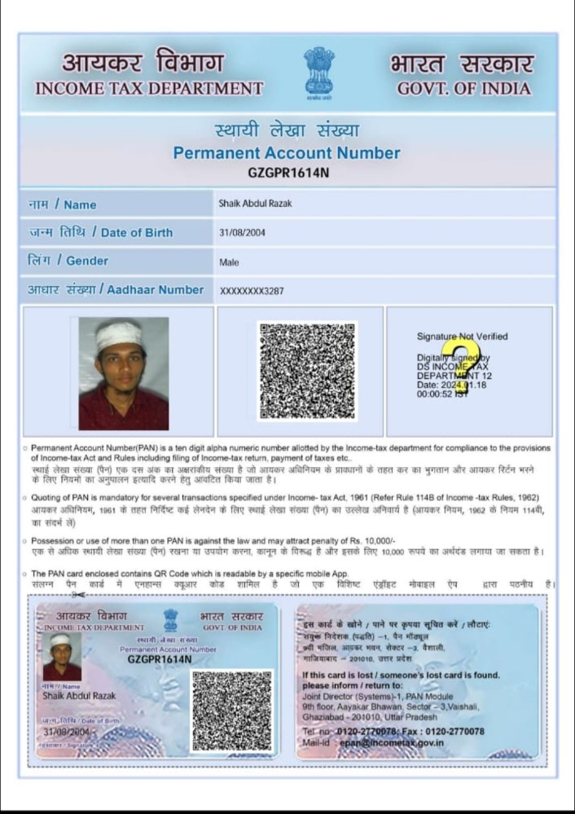
1. Shaik Abdul Razak – Lead Applicant

2. E. Tejaswini – Co-Applicant

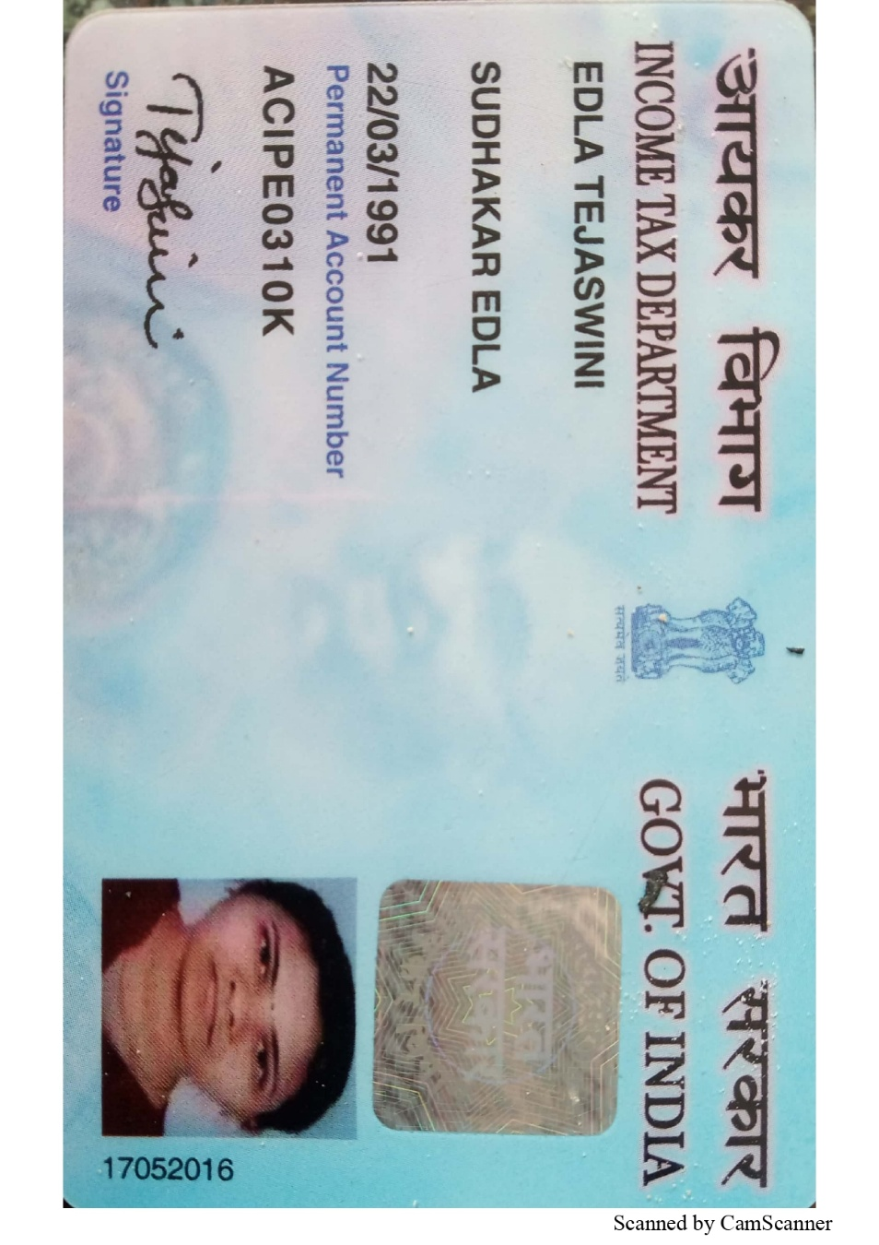

3. Dr. Ramagiri Praveen Kumar – Mentor
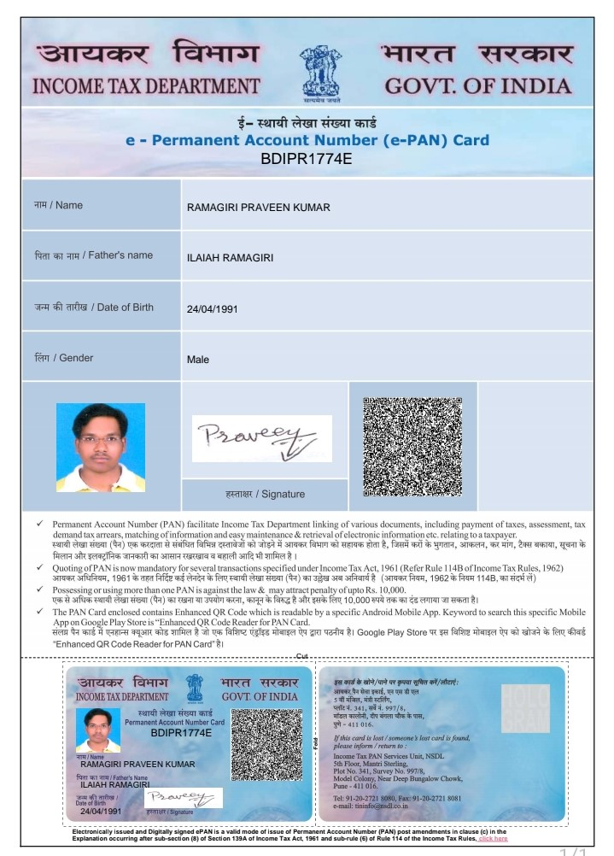

This document is submitted as per the guidelines of Nutrihub, ICAR-IIMR.

